## **Gesture Recognition:** Deep Learning Assignment

* **Jayshree Singh**
* **Manisha Modak**

# Problem Statement

A data scientist at a home electronics company which manufactures state of the art smart televisions, We want to develop a cool feature in the smart-TV that can recognise five different gestures performed by the user which will help users control the TV without using a remote.

🡪 Each gesture corresponds to a specific command:

* Thumbs up:  Increase the volume
* Thumbs down: Decrease the volume
* Left swipe: 'Jump' backwards 10 seconds
* Right swipe: 'Jump' forward 10 seconds
* Stop: Pause the movie

**ß**

**DATA SET :** <https://drive.google.com/uc?id=1ehyrYBQ5rbQQe6yL4XbLWe3FMvuVUGiL>

# Understanding the Dataset

The data is in a zip file. The zip file contains a 'train' and a 'val' folder with two CSV files for the two folders. These folder again has 663 folders, each folder represent a video(contains 30 frames/images).

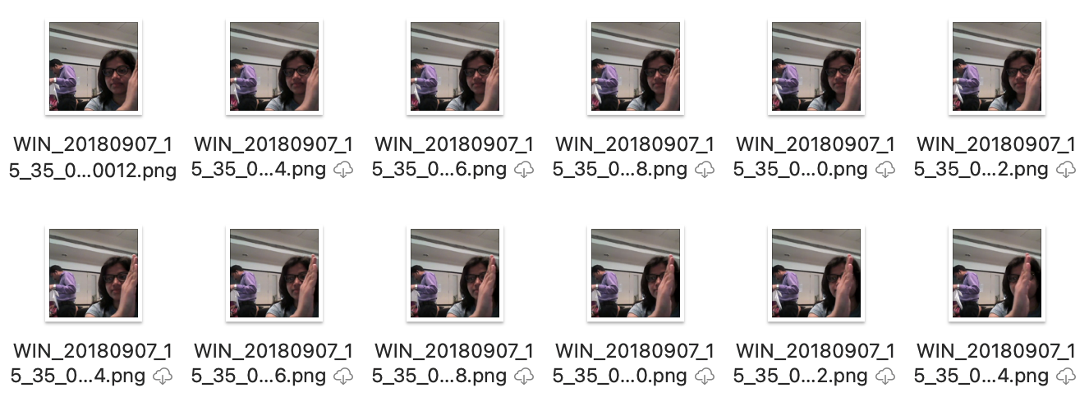

# Objective

Our task is to train different models on the 'train' folder to predict the action performed in each sequence or video and which performs well on the 'val' folder as well. The final test folder for evaluation is withheld - final model's performance will be tested on the 'test' set.

|  |  |  |  |
| --- | --- | --- | --- |
| **Experiment Number** | **Model** | **Result** | **Decision + Explanation** |
| **1** | **Conv3D** | **Throws Generator error** | **Crop the images correctly, try to overfit on less amount of data** |
| **2** | **Conv3D** | **Model not trainable as a lot of parameters** | **Reduce the size of the image/Reduce the number of layers** |
| **3** | **Conv3D** | **Accuracy: 0.21** | **Increase the amount of trainable data/ reduce the filter size** |
|  |  |  |  |
|  |  |  |  |
| **2** | **Conv3D** | **Accuracy: 0.32** | **Reduce Cropping** |
| **3** | **Conv3D** | **Accuracy : 0.38** | **………………** |
|  |  |  |  |
| **l-1th** | **Conv3D** | **Accuracy: 0.45** | **Try ConvLSTM as Conv3D not giving desired accuracy** |
| **lth** | **ConvLSTM** | **Accuracy: …….** | **…………..** |
|  |  |  |  |
| **Final Model** | **……………….** | **………….** | **…………………** |